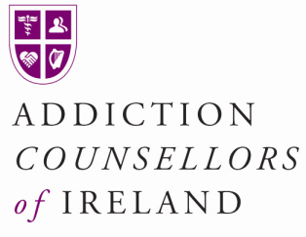

Inactive Accredited Members
Inactive membership can be offered to members who cease counselling for an agreed limited period of time.
It protects their accredited membership status while it also protects the public
Inactive members of the Addiction Counsellors of Ireland cannot offer counselling to clients
Guiding Principles:
- Members must apply in writing giving reasons why they are taking time out
- Must be paid up members at time of applying
- The period of inactive membership is time limited ....i.e. maximum of 2 years
- Members can return to active membership at any given time during that 2 year period
- During the time when inactive they do not need to be in supervision nor attend CPD etc
- Accreditation committee may extend period if circumstances necessitate, based on a written submission
- Inactive members will not be listed in online members register
- Inactive members will enter supervisory relationship approx three month before applying to resume active membership
- A letter from Supervisor will be submitted with application along with evidence of Professional Indemnity Insurance
- Accreditation Committee will deal with applications as speedily as possible

